Pineapple, Mango Salsa Egg Omelette

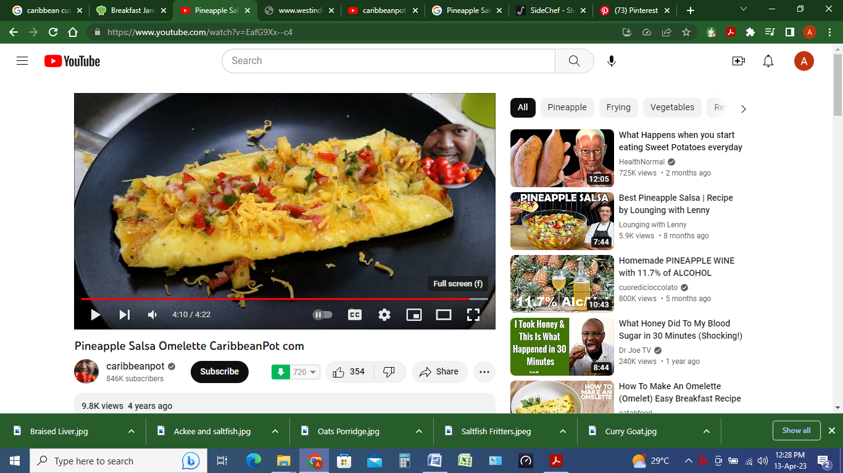

**INGREDIENTS**

**Omelette**

2 Eggs

1 Tbsp Water

2 slices diced bacon

1/4 cup Low-Moisture Part-Skim Mozzarella Cheese , shredded

1/4 tsp Kosher Salt to taste

Ground Black Pepper as needed

Vegetable Oil Cooking Spray

**Salsa**

1 Mango , peeled, diced

1/2 cup Pineapples , diced

¼ Red Bell Pepper

1 Orange Bell Pepper , diced

1 Yellow Bell Pepper , diced

1/4 cup Red Onions , finely chopped

1 Jalapeño Pepper , finely chopped

1 Red Chili Pepper , finely chopped

1 Lime , zested, juiced

3 Tbsp Fresh Cilantro , chopped

1 Tbsp Fresh Mint Leaves , chopped

1 in Fresh Ginger, peeled

**METHOD**

1. Make the Pineapple and Mango Salsa: In a medium bowl, combine Mango (1) , Pineapples (1/2 cup) , Red Bell Pepper (1/4) , Orange Bell Pepper (1) , Yellow Bell Pepper (1) , Red Onions (1/4 cup) , Jalapeño Pepper (1) , and Red Chili Pepper (1) . Toss to combine.
2. Add the Lime (1) , Fresh Cilantro (3 Tbsp) , and Fresh Mint Leaves (1 Tbsp) . Toss to combine.
3. Use a microplane grater to grate the Fresh Ginger (1 in) onto a cutting board. Carefully scoop the ginger pulp into your hand or into a fine mesh sieve. Squeeze the pulp over a small bowl to capture all the ginger juice. Discard the ginger solids. Add the juice to the salsa and toss to combine.
4. Taste for seasonings adding salt and freshly ground pepper, if desired. Set aside.
5. In a small bowl, whisk the Eggs (2) . Add the Water (1 Tbsp) , Kosher Salt (1/4 tsp) and Ground Black Pepper (to taste) . Whisk again until light and fluffy.
6. Heat a small saucepan over medium-high heat until it's very hot, but not scorching. Remove the pan from the heat and liberally spray it with Vegetable Oil Cooking Spray (as needed) . Return the pan to the heat and add the eggs.
7. Swirl the eggs around in the pan so that they coat the bottom and go half way up the sides. Continue this swirling process over the heat until the eggs have mostly set and they are no longer runny.
8. Sprinkle the Bacon (2 slices) onto one half of the eggs. Sprinkle the Low-Moisture Part-Skim Mozzarella Cheese (1/4 cup) over the bacon and then top with Pineapple Mango Salsa.
9. Using a very thin and flexible spatula (a fish spatula if you have one), carefully fold the omelet over on itself and lightly press with the spatula. Continue to cook for 30 seconds or so, holding the top of the omelet in place.
10. Remove from heat and slide the omelet onto a plate. Serve.